
Blue Team Shooting Sports A.S.S.S. February 24th. 2026
COURSE DESIGNER: Ike Starnes

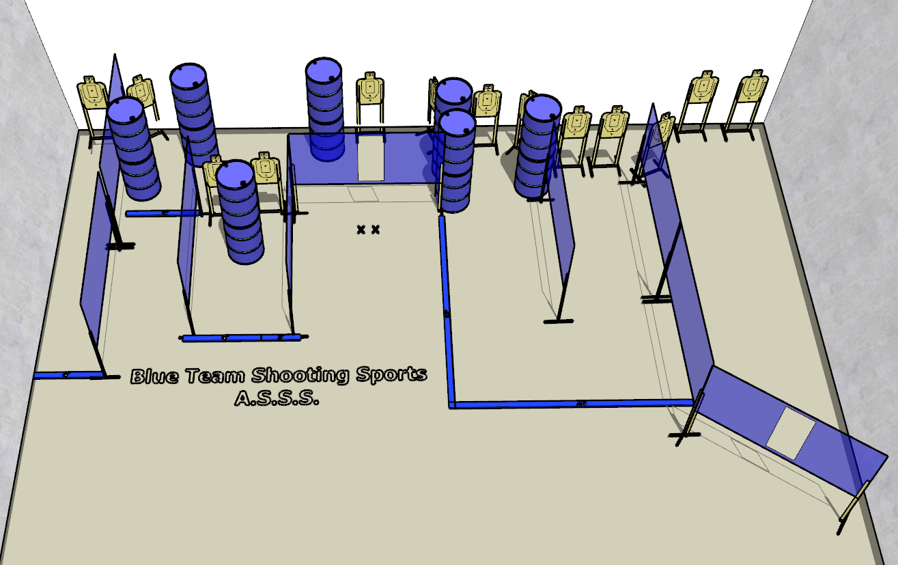

Written Stage Briefings:

Stage 2 – Dying’s easy. You’re gonna learn about pain.- is a 26-round, 130 point, Comstock Course. There are 13 cardboard targets. The best 2 hits per cardboard target will be scored.
Handgun start position Feet on Xs. The handgun is unloaded and holstered, wrists below belt.
PCC start position Feet on Xs. PCC is unloaded, held in both hands, with stock touching belt.
On the audible start signal, engage all targets from within the shooting area.

